SET 4
Q1: A portal needs structured layout. Create a webpage using CSS grid.
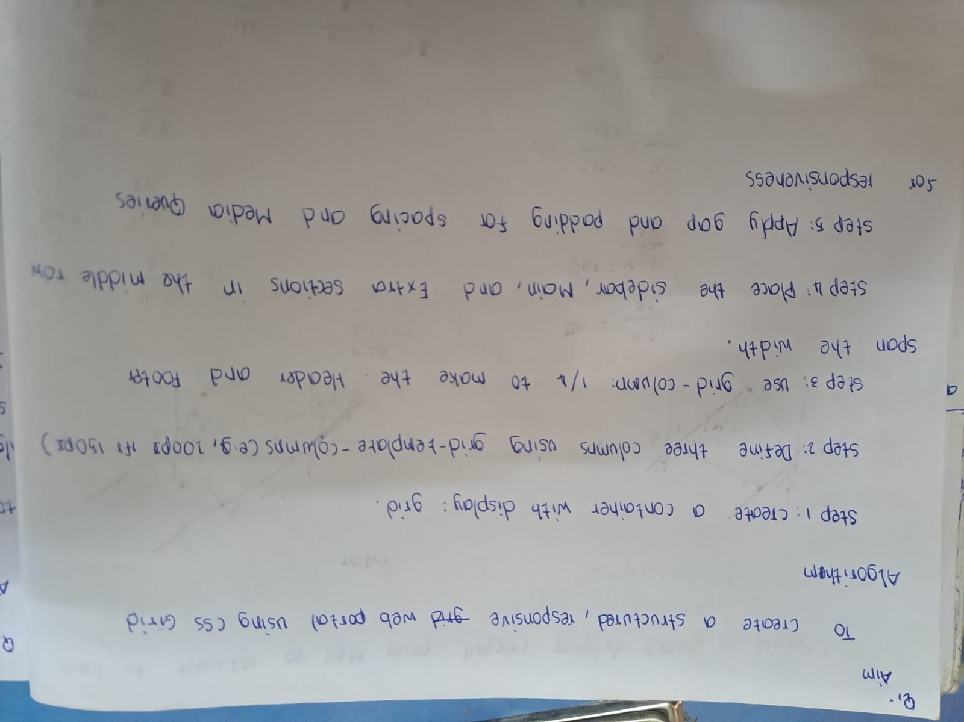
Source code:
<!DOCTYPE html>
<html lang="en">
<head>
<meta charset="UTF-8">
<meta name="viewport" content="width=device-width, initial-scale=1.0">
<title>Simple Light Portal</title>
<style>
body {
font-family: 'Segoe UI', Arial, sans-serif;
background-color: #f9f9fb;
margin: 20px;
color: #333;
}
.container {
display: grid;
grid-template-columns: 220px 1fr 200px; /* Sidebar, Main, Activity */
grid-template-rows: auto 1fr auto;
gap: 15px;
min-height: 90vh;
}
.item {
padding: 20px;
background-color: #ffffff;
border-radius: 8px;
border: 1px solid #e0e4e8;
}
.header {
grid-column: 1 / 4;
background-color: #e3f2fd; /* Light Blue */
display: flex;
justify-content: space-between;
align-items: center;
}
.sidebar {
background-color: #f1f8e9; /* Light Green */
}
.sidebar ul {
list-style-type: none;
padding: 0;
}
.sidebar li {
padding: 10px 0;
border-bottom: 1px solid #ddd;
cursor: pointer;
}
.main {
background-color: #ffffff;
}
.content-box {
background-color: #fff9c4; /* Light Yellow alert box */
padding: 15px;
margin-top: 20px;
border-radius: 5px;
}
.extra {
background-color: #f3e5f5; /* Light Purple */
}
.footer {
grid-column: 1 / 4;
text-align: center;
background-color: #eceff1; /* Light Steel Grey */
font-size: 0.9em;
}
.top-nav span {
margin: 0 10px;
color: #0277bd;
cursor: pointer;
}
@media (max-width: 768px) {
.container {
grid-template-columns: 1fr;
}
.header, .footer {
grid-column: 1;
}
}
</style>
</head>
<body>
<div class="container">
<header class="item header">
<h1>Web Portal</h1>
<nav class="top-nav">
<span>Home</span> | <span>About</span> | <span>Contact</span>
</nav>
</header>
<aside class="item sidebar">
<h3>Dashboard</h3>
<ul>
<li>My Profile</li>
<li>Statistics</li>
<li>Messages</li>
<li>Settings</li>
</ul>
</aside>
<main class="item main">
<h2>Welcome Back!</h2>
<p>This is a structured layout using CSS Grid. It uses light colors to create a clean, modern look for a portal interface.</p>
<div class="content-box">
<p>New updates are available in your area.</p>
</div>
</main>
<section class="item extra">
<h3>Recent Activity</h3>
<p>Last login: 2 mins ago</p>
</section>

<footer class="item footer">
<p>&copy; 2024 Simple Portal Design</p>
</footer>
</div>

</body>
</html>
Output:
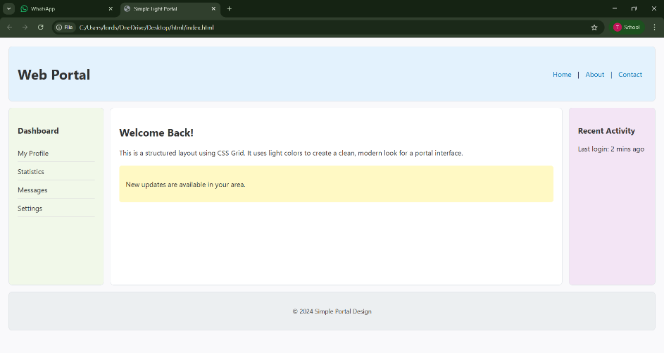
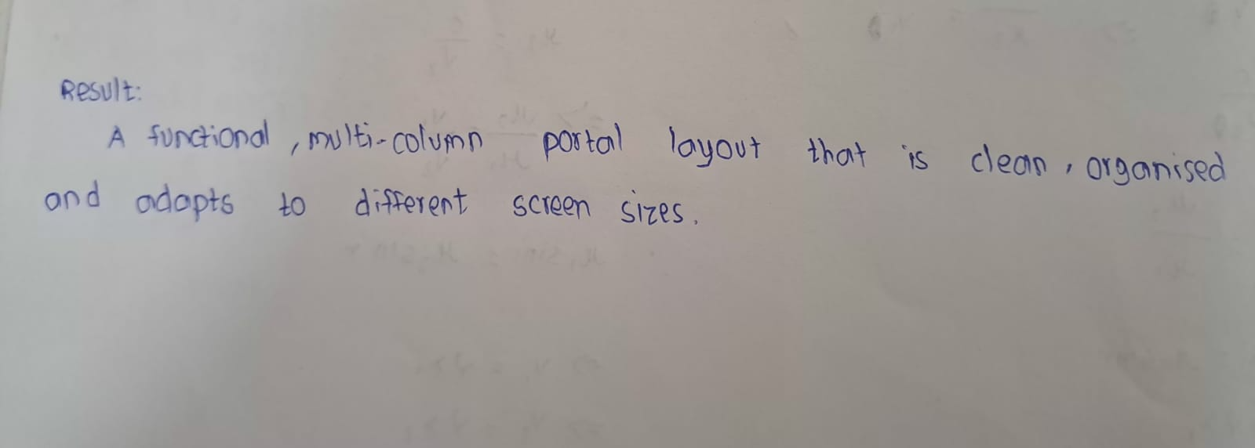

Q2: Write a shell script to add two numbers.
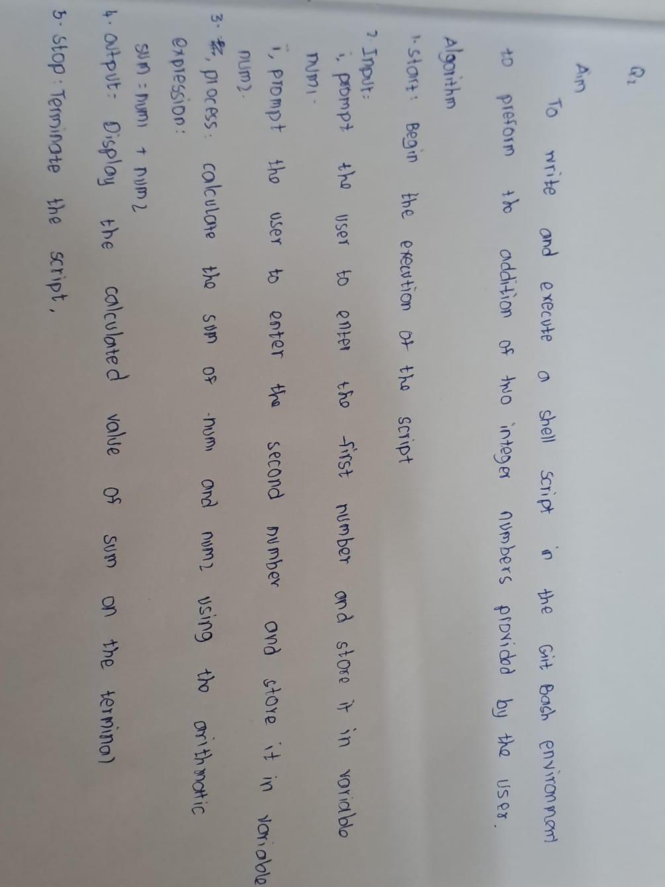
Source Code:
read -p "Enter first number: " num1
read -p "Enter second number: " num2
sum=$((num1 + num2))
echo "The sum is: $sum"

Output:

